STRESSES AND DEFORMATION IN A SOIL MASS
Introduction
In order to solve engineering problems, we must learn to evaluate the stresses acting at a point in a soil mass due to its self weight and also the change in stress that results from any external loading or unloading of the soil from the construction of engineering works. Also of importance is the deformation of a soil mass particularly the settlements that result from such stress changes.

Principle of Effective Stress
In a soil mass, there will be stress within the soil skeleton as a result of the forces acting at the point of contact between individual particles and there will be stresses within the pore fluid occupying the voids of the soil. To study the engineering behavior of soils, we need to be able to distinguish between these two types of stresses and also understand the relationship between them. For this purpose, consider a saturated soil mass of soil having a horizontal surface as shown in the diagram.

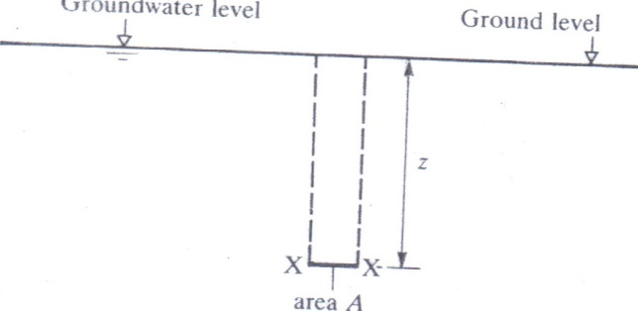

Figure 1. Saturated soil mass with horizontal plane

Let the water table be at ground level. Considering a horizontal plane XX of area $A$ at depth $Z$, the vertical column of soil above X-X will have a total weight W given by:

$$W= W_{s}+ W_{w}$$

Where, $W_{s}=weight of soil particles$
$W_{w}=weight of water in voids$

The soil particles below the water table are subject to an upthrust $U$ so that the effective weight $Ws$ is given by $W_{s}-U$.

$$W_{s}= W_{s}^{'}+ U$$

Substituting for $Ws$

$$W= W_{s}^{'}+ U+ W_{w}$$

Let $V_{s}=volume of soil particles in the column$
$V_{w}=volume of water occupying the pore spaces$

By Archimedes principle, $U= ρ_{w}gV_{s}$

Therefore,
$$W_{w}= ρ_{w}gV_{w}$$

$W= W_{s}^{'}+ ρ_{w}g(V_{s}+ V_{w})$- eqn 1

Since the soil is saturated, the volume water is the volume of void, that is, $V_{w}= V_{v}$

$$V= V_{w}+ V_{s}$$

$$W= W_{s}^{'}+ ρ_{w}gV$$

Dividing both sides of the equation by the area $A$,

$$\frac{W}{A}= \frac{W_{s}^{'}}{A}+ \frac{ρ_{w}gZ}{A}$$

Where,
$total stress= σ= \frac{W}{A}$
$effective stress= σ^{'}= \frac{W_{s}^{'}}{A}$
$pore water pressure=U= \frac{ρ_{w}gZ}{A}$

Therefore,
$$σ= σ^{'}+ U$$

This is the principle of effective stress postulated by Terzaghi which states that at any point in a saturated soil mass, the total stress in any direction is equal to the sum of the effective stress in that direction and the pore water pressure.

Stresses due to Self Weight
The vertical stresses that exist in a soil mass due only to its self weight are referred to as overburden stresses.

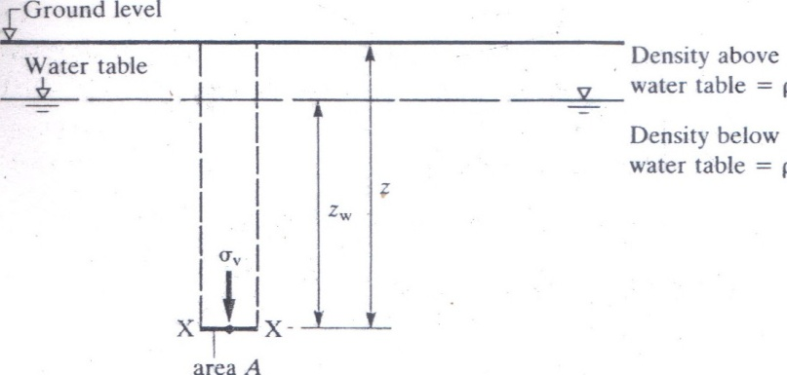

Figure 2. Stresses due to self weight

Considering a horizontal plane XX of area A at depth Z, the total weight of the vertical column (saturated zone + unsaturated zone) of soil above XX is given by:

$$W= ρg\left(Z-Z_{w}\right)A+ ρ_{s}gZ_{w}A$$

Where, $ρ=bulk density of unsaturated soil$
$ρ_{s}=soil saturated density$

Now, the vertical total stress at XX defined as $\frac{W}{A}$ is given by:

$$\frac{W}{A}= σ_{v}= ρg\left(Z-Z_{w}\right)+ ρ_{s}gZ_{w}$$

Pore water pressure, $U,$ below the water table is given by:

$$U= ρ_{w}gZ_{w}$$

Effective over-burden pressure or stress on XX is given by:

$$σ_{v}^{'}= σ_{v}- U$$

$$σ_{v}^{'}=\left[ρg\left(Z-Z_{w}\right)+ ρ_{s}gZ_{w}\right]- ρ_{w}gZ_{w}$$

$$σ_{v}^{'}=ρg\left(Z- Z_{w}\right)+ (ρ_{s}- ρ_{w})gZ_{w}$$

$$σ_{v}^{'}= ρg\left(Z- Z_{w}\right)+ ρ^{'}gZ_{w}$$

Where, $ρ^{'}=effective density of soil$

Example
A soil profile consists of 5m of sand overlying 4m of gravel resting on bed rock. Groundwater is 2 m below horizontal surface of the sand. Determine the distribution of total vertical stress, pore water pressure and effective stress with depth down to bed rock. Given that the bulk density of the sand above the ground water level is 1.70 Mg/m³; the saturated density below the groundwater level is 2.05 Mg/m³; and the saturated density of the gravel is 2.15 Mg/m³. How do these distributions change if the groundwater level is lowered to the sand-gravel interface?

Stresses due to Applied Load
The stress distributions that result in a soil mass due to loads applied by construction of engineering works are influenced by:
- the thickness and uniformity of the soil mass;
- the size and shape of the loaded area; and
- the stress-strain properties of the soil.

However, the stress-strain behavior of real materials is not simple and in case of engineering soils, it is frequently complex. To illustrate the point, the following stress-strain relationships for ideal materials will be provided.

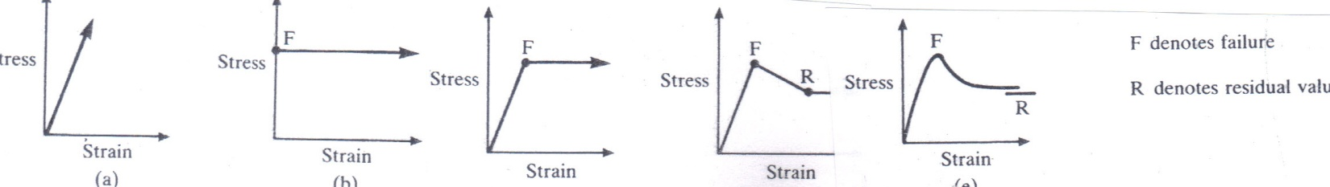

- elastic (b) rigid plastic (c) plastic-elastic (d) elastic-plastic work softening (e) real soil
Figure 3. Stress-strain relationships

In the context of investigating the stress and deformation in a soil mass, there are two (2) categories of engineering problems. These are:
- stability problems; and
- stress distribution and deformation problems.

Stability Problems
Stability problems are analysed by considering the limiting equilibrium of a mass of soil which is on a point of failure by shear along potential slip surface. The soil in the failure zone is assumed to be in a state of plastic equilibrium and in analysis, the soil behavior is defined by a value of shear stress for the soil along the slip surface.

A comparison of the actual stresses on the potential slip surface with these required to generate failure yields a factor of safety against instability. Examples of stability problems include the following:
- earth pressure on retaining walls; and
- the stability of slope and bearing capacity of foundations

Stress Distribution and Deformation Problems
Here, we are primarily interested in predicting stresses and deformations (usually settlements) in the soil when the stress levels are restricted to a working range well below the failure value and lie within the approximately linear initial portion of the stress-strain curve. For these conditions, the soil is assumed to be in a state of equilibrium and the stress distribution and deformation are determined on the assumption that the soil behaves as a homogeneous, isentropic, linearly elastic material whose properties are defined by the modulus of elasticity and the Poisson ratio.

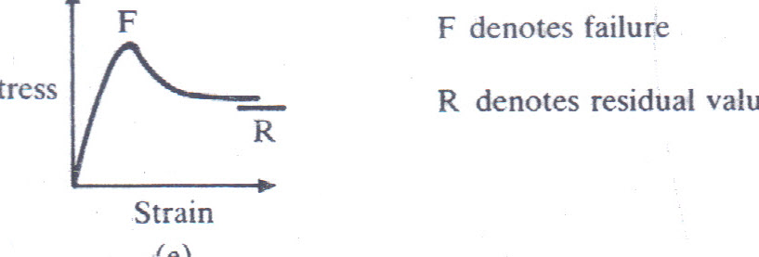

Figure 4. Typical stress-strain relationship of real soil

